



APPROVAL SHEET

FOR

SMD BUZZER

广州粤能科技有限公司
GUANGZHOU YUENENG TECHNOLOGY CO., LTD.

CUSTOMER:

MODEL NO.: YN-DCW9045-16-2703S

OUR PART NO..: CUSTOMER PART NO.:

CUSTOMER | APPROVED | CHECKED

Add: Room 413, Qiaoxing Business Building, Nanda Road Intersection, No. 33 Xingnan Avenue, Nancun Town, Panyu District, Guangzhou City, Guangdong Province

Mobile:+86-18924165988 skype:18924165988

WhatsApp: +86-18924165988 Email: cngzyn@163.com

1

1. Technical Parameter
Measuring condition
Part shall be measured under a condition (Temperature: 5 ～ 35℃ , Humidity: 45% ～ 85%R.H.,
Atmospheric pressure: 860 ～1060mbar) unless the standard condition (Temperature: 25±2℃, Humidity: 60%～70 %R.H. Atmospheric pressure: 860 ～1060mbar) is regulated to measure.
1 | Rated Voltage | 3 Vo-p
2 | Operating Voltage | 2～4Vo-p
3 | Rated Current | Max.90mA
4 | Sound Output at 10cm | Min. 90dB
5 | Coil Resistance | 16±3Ω
6 | Resonant Frequency | 2731Hz
7 | Operating Temperature | -20℃~+70℃
8 | Store Temperature | -30℃~+80℃
9 | Net Weight | Approx 1g
10 | RoHS | Yes
2. Dimensions Unit: mm
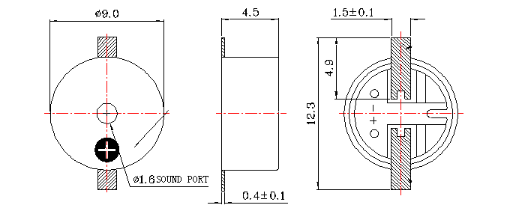
*Unit: mm; Tolerance: ±0.3mm Except Specified *Housing Material: Black LCP
*Terminal plate: 2 soldering pads, tin Plating Brass

3. Electrical And Acoustical Measuring Condition

Recommended Driving Circuit
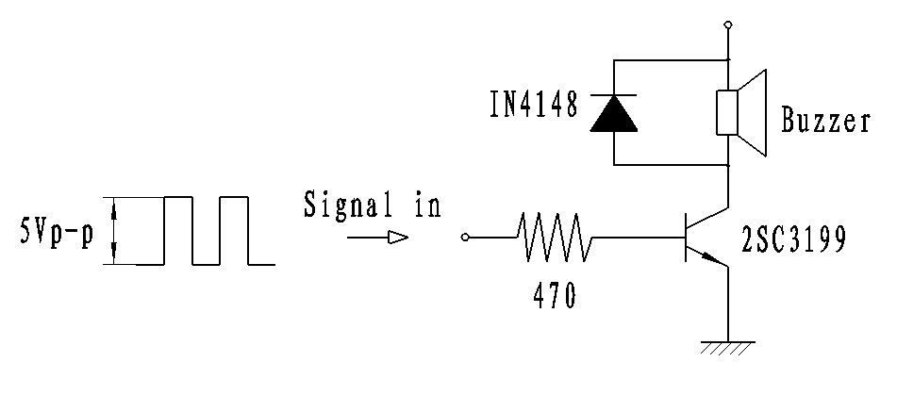
Resonant frequency, 1/2 duty cycle. Square wave. Signal amplitude should be large enough tosaturate the transistor.

Recommended Setting

4. Frequency Response
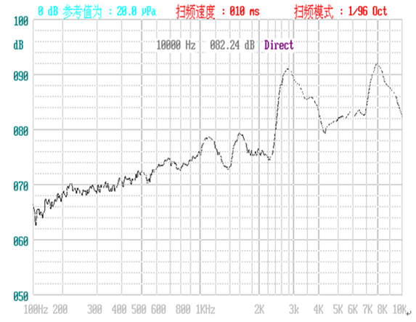
3Vo-p 50% duty Square wave, 10cm

5. Surface mounting condition
5.1 Reflow soldering
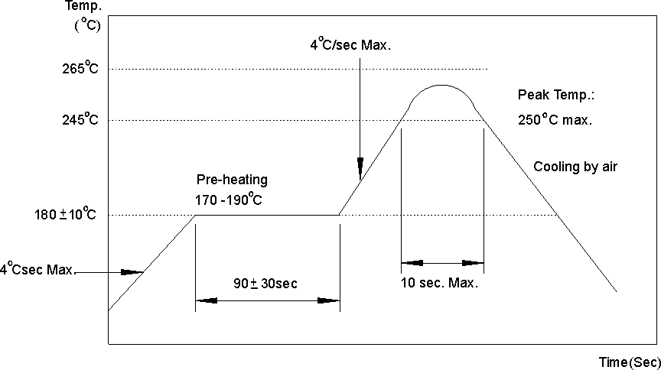
Recommendable reflow soldering condition is as follows.

Note: ( 1) In automated mounting of the SMD sound transducers on PCB, any bending, expanding and pulling forces or shocks against the SMD sound transducers shall be kept minimum
to prevent them from electrical failures and mechanical damages of the devices.
(2) In the reflow soldering, too high soldering temperatures and too large temperature Gradient such as rapid heating or cooling may cause electrical failures and mechanical damages of the devices.
6. Reliability Test
After any following tests the part shall meet specifications without any degradation in appearance and performance except SPL. SPL shall not deviate more than -10 dB from the initial value
6.1 Ordinary Temperature Life Test

The part shall be subjected to 96 hours at 25±10℃ . Input rated voltage

Test Resonant frequency, 1/2 duty Square wave.
6.2 High Temperature

The part shall be capable of with standing a storage temperature of +85℃ for 96 hours.
6.3 Low Temperature Test

The part shall be capable of with standing a storage temperature of -40℃ for 96 hours.
6.4 Humidity Test
Temperature:+40℃±3℃ Relative Humidity:90%～95% Duration: 48 hours

and expose to room temperature for 6 hours
6.5 Temperature Shock Test
Temperature:60℃ / 1hour → 25℃/3hours →-20℃/1hour → 25℃/3hours ( 1cycle)
Total cycle: 10 cycles
6.6 Drop Test
Standard Packaging From 75cm(Drop on hard wood or board of 5cm thick,

three sides, six plain.)
6.7 Vibration Test

Vibration:1000cycles /min. Amplitude:1.5mm, Duration: 1 hour in each 3 axes
6.8 Reflow Test
Use recommendable reflow soldering condition (as shown in 5.1)
( 1) No abnormality should be found after reflow
(2) Good soldering to meet soldering requirements

Note:
As this product is not protected from foreign material entering, please make sure that any foreign materials (e.g. magnetic powder, washing solvent, flux, corrosive gas) do not enter this product in your production processes. The functional degradation (e.g. SPL down) may occur if foreign material enter it.

7. Packing
